US History Name: ______________________________Date: _____________

ARTICLES OF CONFEDERATION WEBQUEST

Part 1: Use the internet to provide definitions for the following terms. KEEP THEM SHORT!!!

Unitary

Confederacy

Federal

Part 2: Use the provided links to answer questions 1-5.

http://www.congressforkids.net/Independence_articles.htm

1. ____________________________________ wrote the Articles of Confederation during the Revolutionary War.

2. Why was the Articles of Confederation written? __________________________________________________________________ __________________________________________________________________

3. What happened after the thirteen colonies became the thirteen states? __________________________________________________________________ __________________________________________________________________

4. The Articles of Confederation became effective on __________________________________.

5. The government was ______________________ after the Articles of Confederation was put into effect.

Part 3: Use the link provided to answer questions 6-11.

http://revolution.mrdonn.org/articlesofconfederation.html

6. Name the six things that Congress could do under the Articles of Confederation:

1) _________________________________________________________

2) _________________________________________________________

3) _________________________________________________________

4) _________________________________________________________

5) _________________________________________________________

6) _________________________________________________________

7. List the 2 things that Congress could not do under the Articles of Confederation:

1) ________________________________________________________

2) ________________________________________________________

8. There was no ______________________ of the central government, and thus no separation of power at the ______________________ (central) level.

9. There was a Congress, and _________________________ states.

10. How many of the 13 states had to approve what Congress did? __________________________________________________________________ __________________________________________________________________

11. The Articles were written to govern a new country, the ______________________________________________. But the Articles were too __________________ to do that effectively.

Part 4: Use the political cartoon provided to answer questions 12 & 13.
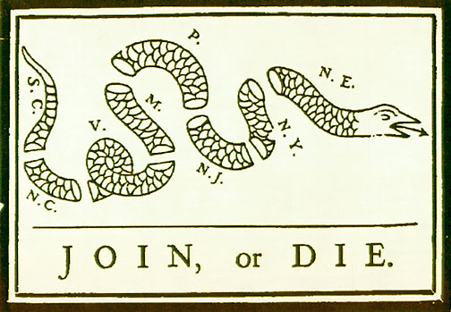

12. The Articles of Confederation call for a loose alliance between the 13 states. What does the political cartoon say about a loose alliance?

_____________________________________________
_____________________________________________

13. Based on the political cartoon, what do the 13 states need to do in order to become successful?

_____________________________________________________________________________

